In order to proceed, one must have ResourceGroup created in Azure website.
Pre-requisites:
- You will have to input your credit card information for this step and create a free azure subscription.
- For Azure database usage, you may have to select pay-as-you-go options, your personal project usually will not exceed the free amount.

- Right click on your project and select publish
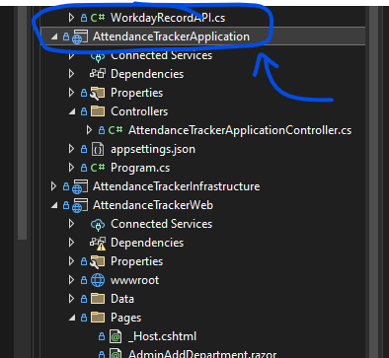
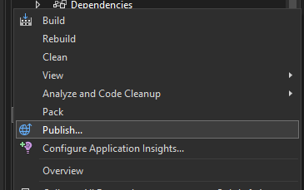

- Then select a new profile if you haven’t already
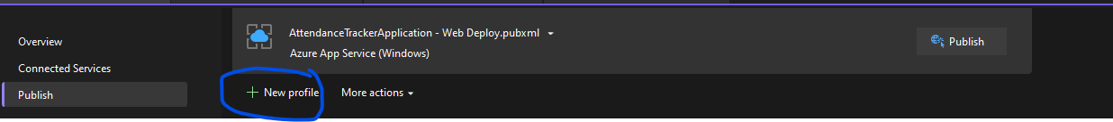
- In the menu pops out, select Azure Azure App Service (Windows).
- If you have signed in to your Microsoft account where the ResourceGroup is registered, you will see it here.
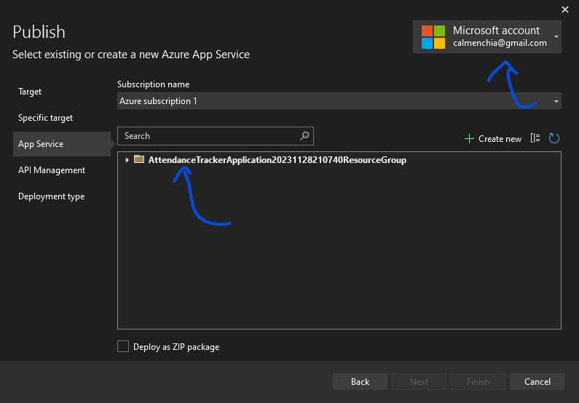

- Then, click on Create New
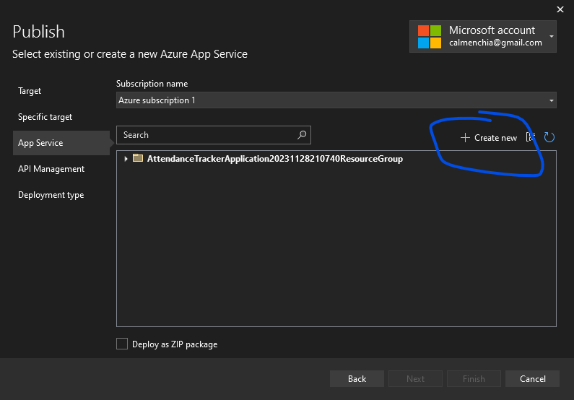
- Select the
- Name (this is what will be shown in Azure management website)
- ResourceGroup that you have registered.
- And the hosting plan accordingly
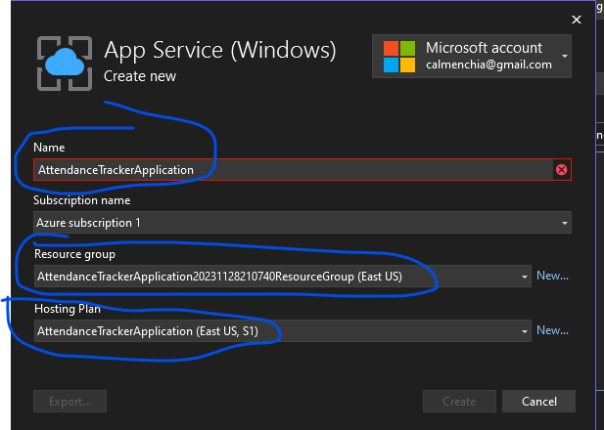
- Click on Next and Finish the publishing.
- Then go to Azure management portal website, login and navigate to Home App Services. We should be able to see our newly created project being hosted now.
